REST API Testing by using SoapUI Tool for testing User Story – US0005

As per Assignment, user story US0005 (Exposing REST APIs) can be tested by using API testing with SoapUI tool (version 5.2.1).

I have created 5 tests for verifying the REST API services (Get Pets list, Add new pet, Get pet by id, Delete pet by id and Update pet by id).

I am providing the REST API test results (after executing SoapUI test scripts) for Pet Store REST API testing. Please see the following screenshots from SoapUI tool.

Executing REST API tests using SoapUI tool:

- Import the PetStore-REST-Services-Assignment-Test-Project.xml, by using SoapUI import option (by choosing file browser option of the folder location of PetStore-REST-Services-Assignment-Test-Project.xml file where it is copied)
- Double click on ‘PetStore-REST-Services-TestSuite’ in the PetStore-REST-Services project in SoapUI tool.
- Click on the green triangle icon to run the tests in the test suite (as shown below screen).

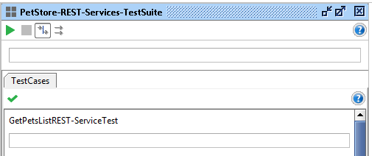

Out of 5 tests...

3 REST API tests are PASSED: Get pets list (GET /api/pets service), Add new pet (POST /api/pets service), Get pet by id (GET /api/pets/{id} service) are working fine and validatted against the service response code and asserted with valid codes(200) by using SoapUI assertions.

2 REST API tests are FAILED: Delete by pet id (DELETE /api/pets/{id} service), Update by pet id (PUT /api/pets/{id} service) are not working fine with the service response.

I am not sure with the issue, as tester I would like to check with development team regarding any issue with the correct resource name end point or method invocation or any parameters issue. Until these issues resolved, I keep these two tests as Failed.

US0005 – Exposing a REST API
Test Suite Test Results Screenshot:

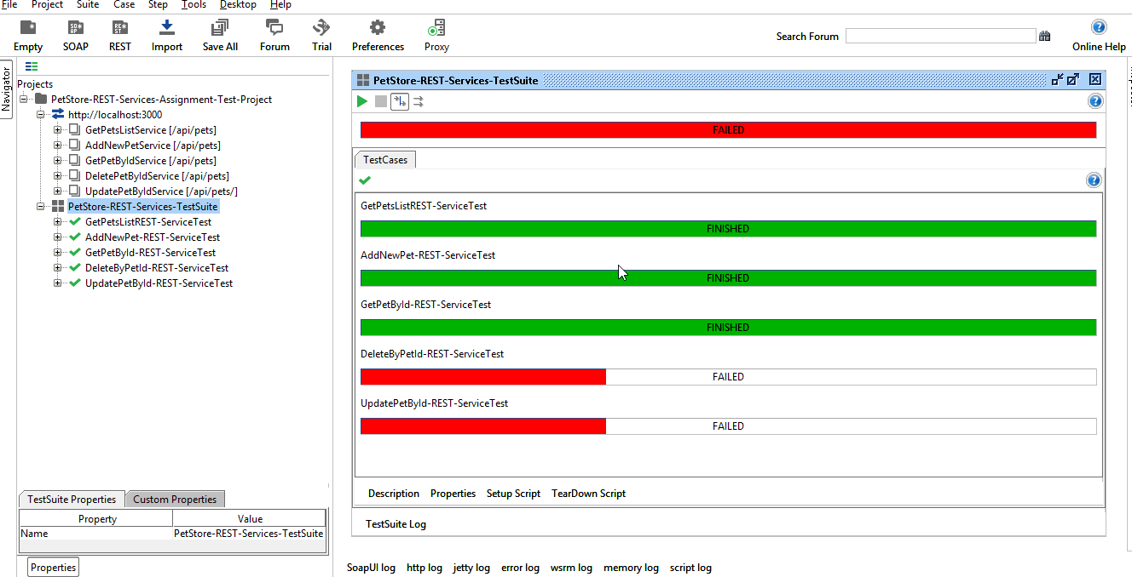

I am providing each REST API request’s response will be shown as following screenshots.

- Get Pets List REST Service request (GET /api/pets service)

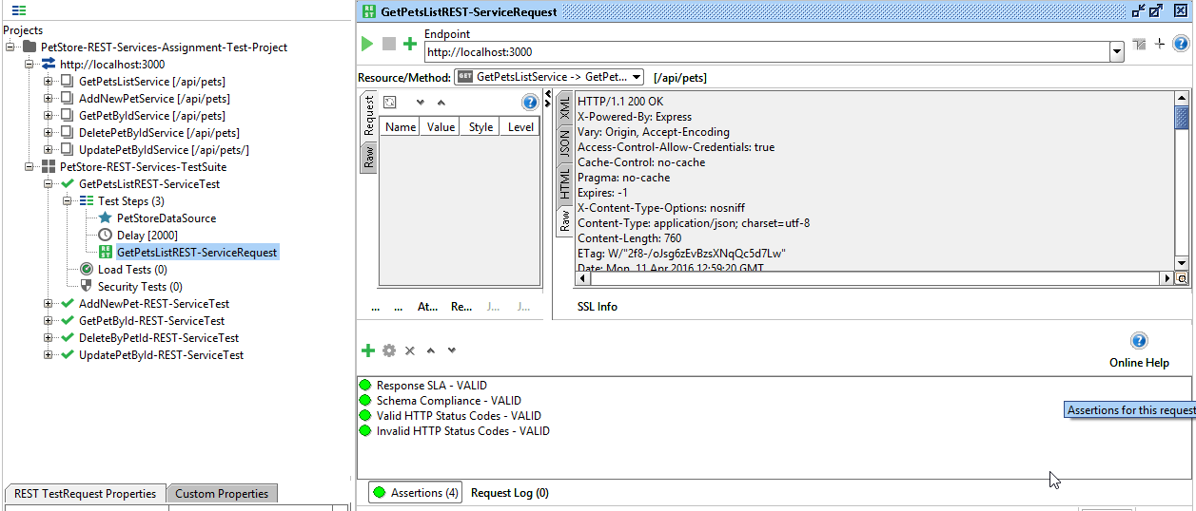

Response is as follows.

HTTP/1.1 200 OK
X-Powered-By: Express
Vary: Origin, Accept-Encoding
Access-Control-Allow-Credentials: true
Cache-Control: no-cache
Pragma: no-cache
Expires: -1
X-Content-Type-Options: nosniff
Content-Type: application/json; charset=utf-8
Content-Length: 672
ETag: W/"2a0-RtmDpM6BQLDUpLzKWC75QA"
Date: Mon, 11 Apr 2016 13:58:12 GMT
Connection: keep-alive

[
{
"id": 1,
"name": "Pluto",
"status": "Sold"
},
{
"id": 2,
"name": "Mickey",
"status": "Sold"
},
{
"name": "Little Mermaid",
"status": "Only one left",
"id": 3
},
{
"name": "Donald",
"status": "Out of stock",
"id": 4
},
{
"id": 5,
"name": "Tom",
"status": "Two left"
},
{
"id": 6,
"name": "Tommy Updated Again",
"status": "Status Already Sold - Updated Again"
},
{
"name": "Tommy",
"status": "Only one left",
"id": 7
},
{
"id": 8,
"name": "Jimmy",
"status": "Four Sold"
},
{
"name": "Parrot",
"status": "Two Sold",
"id": 9
}
]

- Add New Pet REST Service request (POST /api/pets service)

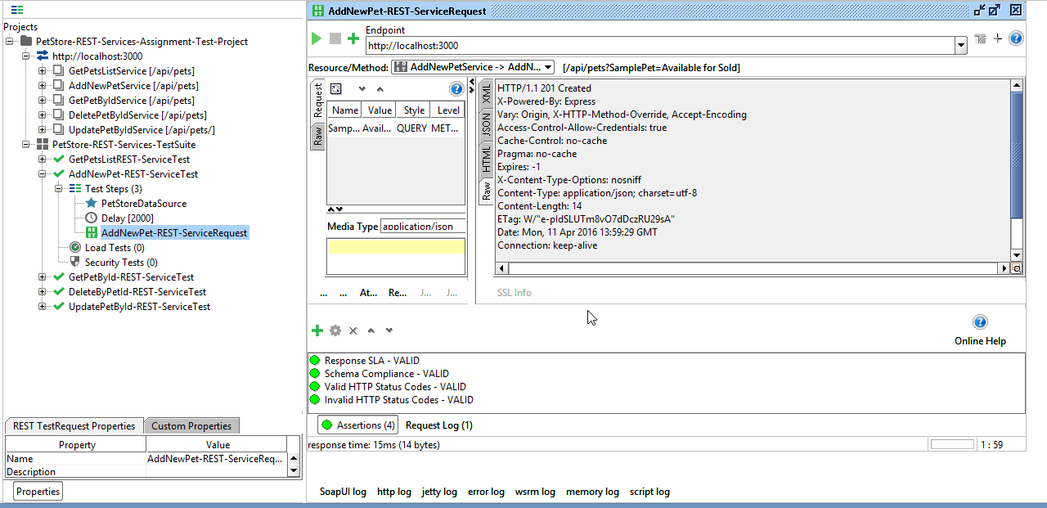

Response as follows:

HTTP/1.1 201 Created
X-Powered-By: Express
Vary: Origin, X-HTTP-Method-Override, Accept-Encoding
Access-Control-Allow-Credentials: true
Cache-Control: no-cache
Pragma: no-cache
Expires: -1
X-Content-Type-Options: nosniff
Content-Type: application/json; charset=utf-8
Content-Length: 14
ETag: W/"e-pIdSLUTm8vO7dDczRU29sA"
Date: Mon, 11 Apr 2016 13:59:29 GMT
Connection: keep-alive

- Get pet by id REST Service request (GET /api/pets/{id} service)

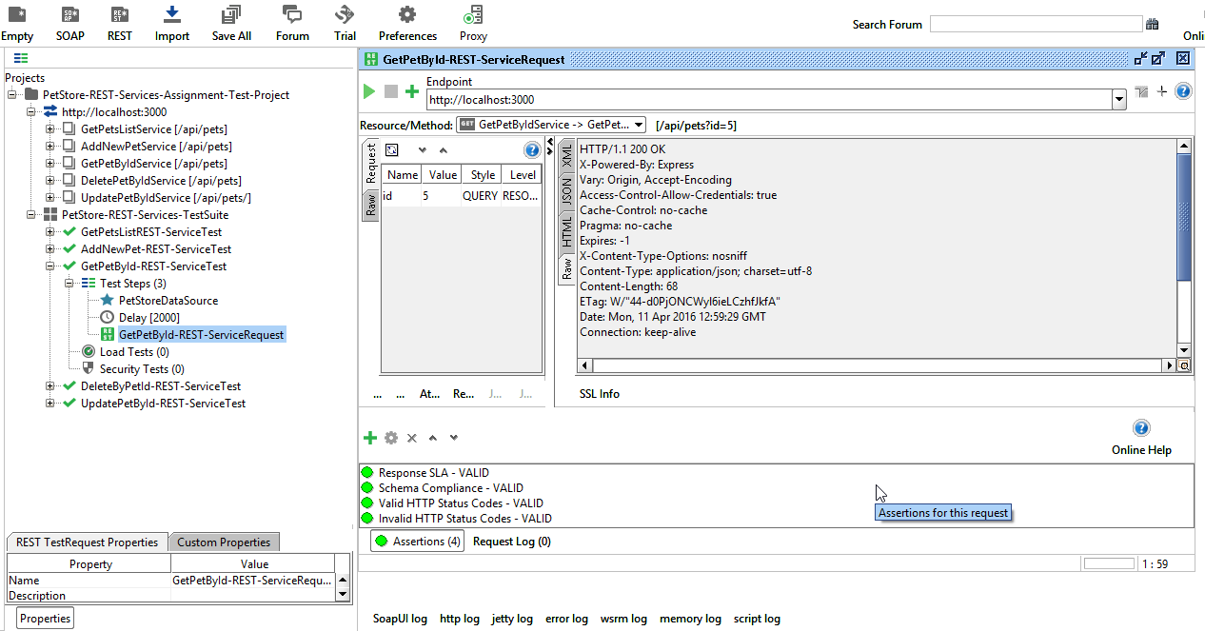

Response is as follows:

HTTP/1.1 200 OK
X-Powered-By: Express
Vary: Origin, Accept-Encoding
Access-Control-Allow-Credentials: true
Cache-Control: no-cache
Pragma: no-cache
Expires: -1
X-Content-Type-Options: nosniff
Content-Type: application/json; charset=utf-8
Content-Length: 68
ETag: W/"44-d0PjONCWyl6ieLCzhfJkfA"
Date: Mon, 11 Apr 2016 12:59:29 GMT
Connection: keep-alive

[
{
"id": 5,
"name": "Tom",
"status": "Two left"
}
]

- Delete by pet Id REST request (DELETE /api/pets/{id} service)

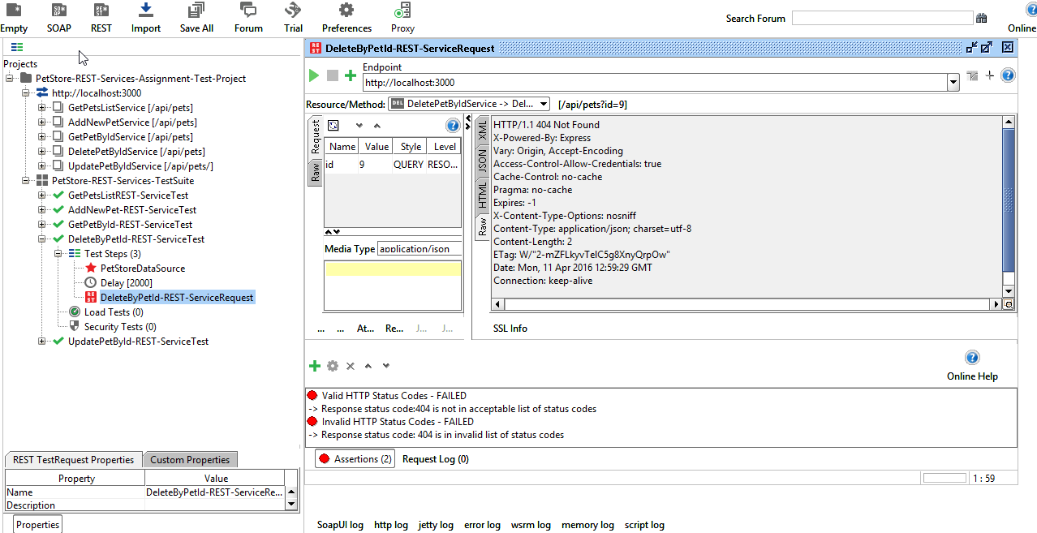

Response is as follows: Failed – due to 404 not found in response

HTTP/1.1 404 Not Found
X-Powered-By: Express
Vary: Origin, Accept-Encoding
Access-Control-Allow-Credentials: true
Cache-Control: no-cache
Pragma: no-cache
Expires: -1
X-Content-Type-Options: nosniff
Content-Type: application/json; charset=utf-8
Content-Length: 2
ETag: W/"2-mZFLkyvTelC5g8XnyQrpOw"
Date: Mon, 11 Apr 2016 12:59:29 GMT
Connection: keep-alive

{}

- Update pet by id REST Service Request (PUT /api/pets/{id} service)

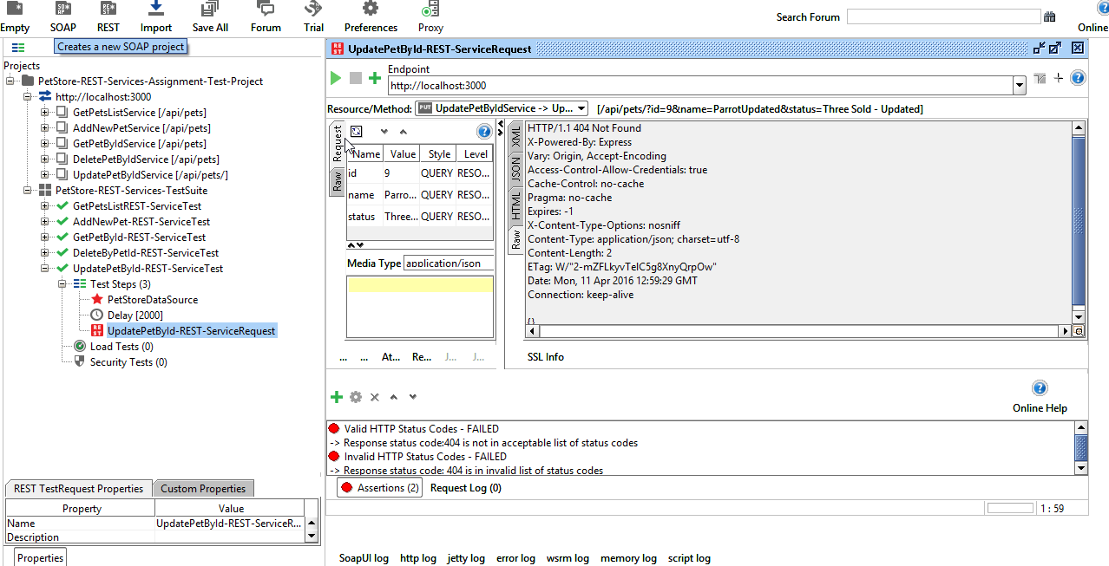

Response is as follows: Failed – due to 404 not found in response

HTTP/1.1 404 Not Found
X-Powered-By: Express
Vary: Origin, Accept-Encoding
Access-Control-Allow-Credentials: true
Cache-Control: no-cache
Pragma: no-cache
Expires: -1
X-Content-Type-Options: nosniff
Content-Type: application/json; charset=utf-8
Content-Length: 2
ETag: W/"2-mZFLkyvTelC5g8XnyQrpOw"
Date: Mon, 11 Apr 2016 14:16:02 GMT
Connection: keep-alive

{}

